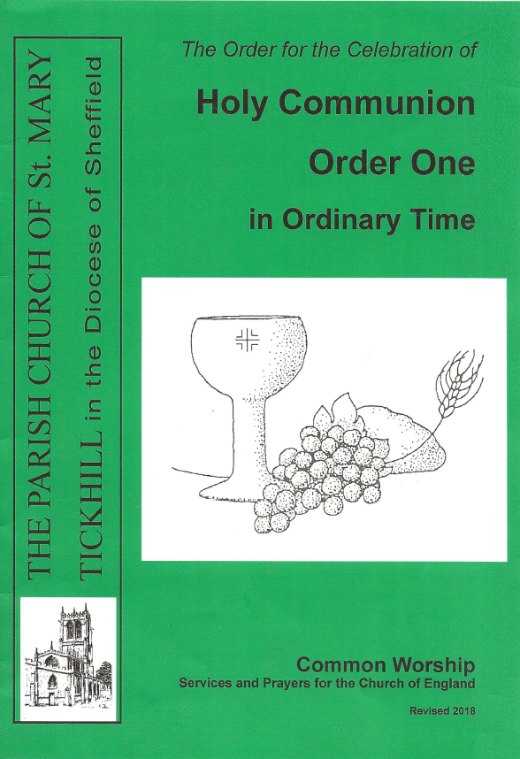
THE PARISH OF TICKHILL
The Order of Holy Communion
Order One in Ordinary Time
THE GATHERING
Stand
At the entry of the choir and ministers a hymn is sung

The Greeting
Remain standing
The president says
In the name of the Father, and of the Son,
and of the Holy Spirit.
Amen.
The president greets the people
The Lord be with you
and also with you.

Prayer of Preparation
Kneel or sit
Almighty God,
to whom all hearts are open,
all desires known,
and from whom no secrets are hidden:
cleanse the thoughts of our hearts
by the inspiration of your Holy Spirit,
that we may perfectly love you,
and worthily magnify your holy name;
through Christ our Lord.
Amen.
Prayers of Penitence
Remain kneeling or sitting

Summary of the Law

Our Lord Jesus Christ said:
The first commandment is this:
'Hear, O Israel, the Lord our God is the only Lord.
You shall love the Lord your God with all your heart,
with all your soul, with all your mind,
and with all your strength.'
The second is this: 'Love your neighbour as yourself.'
There is no other commandment greater than these.
On these two commandments hang all the law and the prophets.
Amen. Lord, have mercy.

Invitation to Confession

God so loved the world
that he gave his only Son Jesus Christ
to save us from our sins,
to be our advocate in heaven,
and to bring us to eternal life.
Let us confess our sins in penitence and faith, firmly resolved to keep God's commandments and to live in love and peace with all.

Confession
Remain kneeling or sitting

Almighty God, our heavenly Father,
we have sinned against you
and against our neighbour
in thought and word and deed,
through negligence, through weakness,
through our own deliberate fault.
We are truly sorry
and repent of all our sins.
For the sake of your Son Jesus Christ,
who died for us,
forgive us all that is past
and grant that we may serve you in newness of life
to the glory of your name.
Amen.

The president says
Almighty God,
who forgives all who truly repent,
have mercy upon you,
pardon and deliver you from all your sins,
confirm and strengthen you in all goodness,
and keep you in life eternal;
through Jesus Christ our Lord.
Amen.

Gloria in Excelsis
Stand

Glory to God in the highest,
and peace to his people on earth.
Lord God, heavenly King,
almighty God and Father,
we worship you, we give you thanks,
we praise you for your glory.
Lord Jesus Christ, only Son of the Father,
Lord God, Lamb of God,
you take away the sin of the world:
have mercy on us;
you are seated at the right hand of the Father:
receive our prayer.
For you alone are the Holy One,
you alone are the Lord,
you alone are the Most High, Jesus Christ,
with the Holy Spirit,
in the glory of God the Father.

Amen.

The Collect
Remain standing

The Collect is said, and all respond
Amen.

At this point the younger members of the church may leave for their own activities ...

THE LITURGY OF THE WORD

The First & Second Readings
Sit

At the end of each
This is the word of the Lord.
Thanks be to God.

Hymn
Stand

The Gospel Reading
Remain standing

A Gospel Acclamation may be used
Response: Alleluia

Hear the Gospel of our Lord Jesus Christ according to N.
Glory to you, O Lord.

At the end
This is the Gospel of the Lord.
Praise to you, O Christ.

The Sermon
Sit

The Nicene Creed
We believe in one God,
the Father, the Almighty,
maker of heaven and earth,
of all that is,
seen and unseen.
We believe in one Lord, Jesus Christ,
the only Son of God,
eternally begotten of the Father,
God from God, Light from Light,
true God from true God,
begotten, not made,
of one Being with the Father;
through him all things were made.
For us and for our salvation he came down from heaven,
was incarnate from the Holy Spirit and the Virgin Mary
and was made man.
For our sake he was crucified under Pontius Pilate;
he suffered death and was buried.
On the third day he rose again
in accordance with the Scriptures;
he ascended into heaven
and is seated at the right hand of the Father.
He will come again in glory
to judge the living and the dead,
and his kingdom will have no end,
We believe in the Holy Spirit,
the Lord, the giver of life,
who proceeds from the Father and the Son,
who with the Father and the Son
is worshipped and glorified,
who has spoken through the prophets.
We believe in one holy catholic and apostolic Church.
We acknowledge one baptism
for the forgiveness of sins.
We look for the resurrection of the dead,
and the life of the world to come.
Amen
PRAYERS OF INTERCESSION
Kneel or sit
The following or other prayers may be used ...
In the power of the Spirit and in union with Christ, let us pray to the Father.
This response may be used
Lord, in your mercy
hear our prayer.
Almighty God, our heavenly Father, you promised through your Son Jesus Christ to hear us when we pray in faith.
Strengthen N and N our bishops and all your Church in the service of Christ, that those who confess your name may be united in your truth, live together in your love, and reveal your glory in the world.
Bless and guide Elizabeth our Queen; give wisdom to all in authority; and direct this and every nation in the ways of justice and of peace; that we may honour one another, and seek the common good.
Give grace to us, our families and friends, and to all our neighbours, that we may serve Christ in one another, and love as he loves us.
Comfort and heal all those who suffer in body, mind, or spirit .
give them courage and hope in their troubles; and bring them the joy of your salvation.
Hear us as we remember those who have died in the faith of Christ ... according to your promises, grant us with them a share in your eternal kingdom.
Rejoicing in the fellowship of all your saints, we commend ourselves and the whole creation to your unfailing love.
Merciful Father,
accept these prayers for the sake of your Son,
our Saviour Jesus Christ.
Amen

THE LITURGY OF THE SACRAMENT

The Peace
Stand

The Peace may be introduced with a suitable sentence, and then the president says

The peace of the Lord be always with you
and also with you.

Let us offer one another a sign of peace.
All may share the peace with their neighbours

Preparation of the Table
Taking of the Bread and Wine
Remain standing

Hymn
The collection is taken. The gifts of the people are presented. The younger members of the church may return ...

Either
God of life, saviour of the poor,
receive with this money
gratitude for your goodness,
penitence for our pride
and dedication to your service
in Jesus Christ our Lord.
Amen.
or
Be present, be present,
Lord Jesus Christ,
our risen high priest;
make yourself known in the breaking of bread.
Amen
Either this Eucharistic Prayer is used or the one on Page 11

The Eucharistic Prayer
Remain standing
The Lord is here.
His Spirit is with us.

Lift up your hearts.
We lift them to the Lord.

Let us give thanks to the Lord our God.
It is right to give thanks and praise.

Father, we give you thanks and praise
through your beloved Son Jesus Christ, your living Word,
through whom you have created all things;
who was sent by you in your great goodness to be our Saviour.
By the power of the Holy Spirit he took flesh;
as your Son, born of the blessed Virgin,
he lived on earth and went about among us;
he opened wide his arms for us on the cross;
he put an end to death by dying for us;
and revealed the resurrection by rising to new life;
so he fulfilled your will and won for you a holy people.
Short Proper Preface, when appropriate
Therefore with angels and archangels,
and with all the company of heaven,
we proclaim your great and glorious name,
for ever praising you and saying:

Holy, holy, holy Lord,
God of power and might,
heaven and earth are full of your glory.
Hosanna in the highest.
Blessed is he who comes in the name of the Lord.
Hosanna in the highest.
Lord, you are holy indeed, the source of all holiness;
grant that by the power of your Holy Spirit,
and according to your holy will,
these gifts of bread and wine
may be to us the body and blood of our Lord Jesus Christ;

who, in the same night that he was betrayed,
took bread and gave you thanks;
he broke it and gave it to his disciples, saying:
Take, eat; this is my body which is given for you;
do this in remembrance of me.

In the same way, after supper
he took the cup and gave you thanks;
he gave it to them, saying:
Drink this, all of you; this is my blood of the new covenant,
which is shed for you and for many for the forgiveness of sins.
Do this, as often as you drink it, in remembrance of me.

Great is the mystery of faith:

Christ has died:
Christ is risen:
Christ will come again.

And so, Father, calling to mind his death on the cross,
his perfect sacrifice made once for the sins of the whole world;
rejoicing in his mighty resurrection and glorious ascension,
and looking for his coming in glory,
we celebrate this memorial of our redemption.

As we offer you this our sacrifice
of praise and thanksgiving,
we bring before you this bread and this cup
and we thank you for counting us worthy
to stand in your presence and serve you.

Send the Holy Spirit on your people
and gather into one in your kingdom
all who share this one bread and one cup,
so that we, in the company of [N and ] all the saints,
may praise and glorify you for ever,
through Jesus Christ our Lord;

by whom, and with whom, and in whom,
in the unity of the Holy Spirit,
all honour and glory be yours, almighty Father,
for ever and ever.
Amen.

The service continues with the Lord's Prayer on page 14

The Eucharistic Prayer
Remain standing
The Lord is here.
His Spirit is with us.

Lift up your hearts.
We lift them to the Lord.

Let us give thanks to the Lord our God.
It is right to give thanks and praise.

Blessed are you, Lord God,
our light and our salvation;
to you be glory and praise for ever.
From the beginning you have created all things
and all your works echo the silent music of your praise.

In the fullness of time you made us in your image,
the crown of all creation.
You give us breath and speech,
that with angels and archangels and all the powers of heaven
we may find a voice to sing your praise:
Holy, holy, holy Lord,
God of power and might,
heaven and earth are full of your glory.
Hosanna in the highest.
Blessed is he who comes in the name of the Lord.
Hosanna in the highest.

How wonderful the work of your hands, O Lord.
As a mother tenderly gathers her children,
you embraced a people as your own.
When they turned away and rebelled
your love remained steadfast.
From them you raised up Jesus our Saviour, born of Mary,
to be the living bread,
in whom all our hungers are satisfied.
He offered his life for sinners,
and with a love stronger than death
he opened wide his arms on the cross.

On the night before he died,
he came to supper with his friends
and, taking bread, he gave you thanks.
He broke it and gave it to them, saying:
Take, eat; this is my body which is given for you;
do this in remembrance of me.

At the end of supper, taking the cup of wine,
he gave you thanks, and said:
Drink this, all of you; this is my blood of the new covenant,
which is shed for you and for many for the forgiveness of sins.
Do this, as often as you drink it, in remembrance of me.

Great is the mystery of faith:

Christ has died:
Christ is risen:
Christ will come again,

Father, we plead with confidence
his sacrifice made once for all upon the cross;
we remember his dying and rising in glory,
and we rejoice that he intercedes for us at your right hand.

Pour out your Holy Spirit as we bring before you
these gifts of your creation;
may they be for us the body and blood of your dear Son.
As we eat and drink these holy things in your presence,
form us in the likeness of Christ,
and build us into a living temple to your glory.

Bring us at the last with all the saints
to the vision of that eternal splendour
for which you have created us;
through Jesus Christ, our Lord,
by whom, with whom, and in whom,
with all who stand before you in earth and heaven,
we worship you, Father almighty,
in songs of everlasting praise:

Blessing and honour and glory and power
Be yours for ever and ever.
Amen.
The Lord's Prayer
Kneel or sit
As our Saviour taught us, so we pray
Our Father in heaven,
hallowed be your name,
your kingdom come, your will be done,
on earth as in heaven.
Give us today our daily bread.
Forgive us our sins
as we forgive those who sin against us.
Lead us not into temptation
but deliver us from evil.
For the kingdom, the power,
and the glory are yours
now and for ever. Amen.
Breaking of the Bread
The president breaks the consecrated bread
Either or
We break this bread Every time we eat this bread
to share in the body of Christ and drink this cup,
Though we are many, we proclaim the Lord's death
we are one body, until he comes.
because we all share in
one bread.
Either
Lamb of God, you take away the sin of the world,
have mercy on us.
Lamb of God, you take away the sin of the world,
have mercy on us.
Lamb of God, you take away the sin of the world,
grant us peace,
or
Jesus, Lamb of God, have mercy on us.
Jesus, bearer of our sins, have mercy on us.
Jesus, redeemer of the world, grant us peace.

Giving of Communion
Either
Draw near with faith.
Receive the body of our Lord Jesus Christ
which he gave for you, and his blood which he shed for you.
Eat and drink in remembrance that he died for you,
and feed on him in your hearts
by faith with thanksgiving.

God's holy gifts for God's holy people.
Jesus Christ is holy,
Jesus Christ is Lord,
to the glory of God the Father.

We do not presume
to come to this your table, merciful Lord,
trusting in our own righteousness,
but in your manifold and great mercies.
We are not worthy
so much as to gather up the crumbs under your table.
But you are the same Lord
whose nature is always to have mercy.
Grant us therefore, gracious Lord,
so to eat the flesh of your dear Son Jesus Christ
and to drink his blood,
that our sinful bodies may be made clean by his body
and our souls washed through his most precious blood,
and that we may evermore dwell in him, and he in us.
Amen.
The president and people receive communion.
During the distribution of communion, hymns and anthems may be sung, otherwise silence is kept
If you do not normally receive communion but wish to come for a Blessing, then please carry this service book in your hands when you come to the altar rail

Prayer after Communion
Kneel or sit

The President says the Post Communion prayer and continues...

Let us give thanks

Almighty God,
we thank you for feeding us
with the body and blood of your Son Jesus Christ.
Through him we offer you our souls and bodies
to be a living sacrifice.
Send us out in the power of your Spirit
to live and work to your praise and glory.
Amen.

THE DISMISSAL
Blessing
Remain kneeling or sitting

[The peace of God, which passes all understanding, keep
your hearts and minds in the knowledge and love of God,
and of his Son Jesus Christ our Lord;]
and the blessing of God almighty,
the Father, the Son, and the Holy Spirit,
be among you and remain with you always.
Amen.

Notices may be announced or Banns of Marriage may be read

Hymn
Stand

Go in peace to love and serve the Lord.
In the name of Christ. Amen.

